

**Research & Vehicle Technology**

**“Infotainment Systems Product Development”**

**Drive Video Record**

**Feature Level Specification**

Version 1.4

**UNCONTROLLED COPY IF PRINTED**

**Version Date: Nov. 10, 2022**

**FORD CONFIDENTIALF**

**Revision History**

|  |  |  |  |
| --- | --- | --- | --- |
| **Date** | **Ver** | **Notes** | |
| **April. 17, 2022** | **1.0** | * **Initial Release** | **Niu, Kobe (Y.) initial.** |
| **June. 29, 2022** | **1.1** | * **Update according to benchmark** | **Niu, Kobe (Y.) update.** |
| **July. 25, 2022** | **1.2** | * **Update according to HMI UE input** | **Niu, Kobe (Y.) update.** |
| **Sep. 05, 2022** | **1.3** | * **Update section 1.1 system B-Diagram** * **Update section 2.6 DVR interface** * **Add DVR EOL requirement in section 3.6** * **Update section 3.7 vehicle data collection** * **Update section 4.2 video/photo record** * **Add timeout logic in section 4.3.1** * **Add screenshot function in section 4.2.1.5** * **Wording and image optimization for all sections** | **Niu, Kobe (Y.) update.** |
| **Nov. 10, 2022** | **1.4** | * **Add description about functions which will not be supported on DVROffboardClient** * **Update according to function team review** * **Update according to UE V3.5.0** | **Niu, Kobe (Y.) update.** |
| **Dec. 02, 2022** | **1.5** | * **Section 4.2.3.2.3 Manual Video Record sequence diagram update** * **Section 4.2.1.7 All DVR video should support watermark** * **Section 3.1 Power management strategy update** * **Section 4.2.1.1 update TF card file system design** | **Niu, Kobe (Y.) update.** |
|  |  |  |  |

**Table of Contents**

Revision History 2

1 Overview 5

1.1 System Diagram 5

1.2 Terminology and Abbreviations 5

2 Architectural Design 6

2.1 XXXXX-REQ-xxxxxx/A-DVR User 6

2.2 XXXXX-REQ-xxxxxx/A-DVR Onboard Client 6

2.3 XXXXX-REQ-xxxxxx/A-DVR Offboard Client 6

2.4 XXXXX-REQ-xxxxxx/A-DVR server 6

2.5 Physical Mapping of Classes 6

2.6 Signal Mapping 6

2.7 DVRServer Interface 6

3 General Requirements 7

3.1 XXXXX-REQ-xxxxxx/A-Power Mode Design 7

3.1.1 Full Power Mode 7

3.1.2 Standby Mode 7

3.1.3 Sleep Mode 7

3.1.4 Power Mode Switch 7

3.2 XXXXX-REQ-xxxxxx/A-Preconditions of Recording 7

3.3 XXXXX-REQ- xxxxxx /A-AR Camera Integration 8

3.4 XXXXX-REQ- xxxxxx /A-Legal Regulation 8

3.5 XXXXX-REQ- xxxxxx /A-DVR System Communication 8

3.6 XXXXX-REQ- xxxxxx /A-EOL Requirement 8

3.7 XXXXX-REQ- xxxxxx /A-Vehicle Data Collection 8

4 Functional Definition 9

4.1 XXXXX-FUN-REQ-xxxxxx/A-Enable/Disable Normal Video Record 9

4.1.1 Requirements 9

4.1.2 Use Cases 9

4.1.3 White Box View 11

4.2 XXXXX-FUN-REQ-xxxxxx/A-Video/Photo Data Record and Save 14

4.2.1 Requirements 14

4.2.2 Use Cases 16

4.2.3 White Box View 17

4.3 XXXXX-FUN-REQ-xxxxxx/A-Video/Photo Display 23

4.3.1 Requirements 23

4.3.2 Use Cases 24

4.3.3 White Box View 25

4.4 XXXXX-FUN-REQ-xxxxxx/A-DVR Setting & Information Display 27

4.4.1 Requirements 27

4.4.2 Use Cases 29

4.4.3 White Box View 30

4.5 XXXXX-FUN-REQ-xxxxxx/A-Data Copy and Deletion 31

4.5.1 Requirements 31

4.5.2 Use Cases 32

4.5.3 White Box View 34

4.6 XXXXX-FUN-REQ-xxxxxx/A-Vehicle Monitoring 36

4.6.1 Requirements 36

4.6.2 Use Cases 37

4.6.3 White Box View 38

5 Appendix: Reference Documents 39

# Overview

The Drive Video Record (DVR) feature allows the user to capture video and photo from a dash camera while driving, and customer could save the data to an external TF card or download to smart phone via Wi-Fi, The DVR camera is mounted behind the vehicle windshield glass without the obstruction from interior components.

The DVR system could capture the video of exterior environment automatically, and when collision happening, DVR will capture/save a special video labeled as “emergency video”, user could also trigger the video or photo recording manually to save the beautiful view or important scene, at the same time the necessary information like VIN, date, time will be saved as watermark. Users could also playback the video via the center stack or Ford APP, DVR will also provide vehicle monitor function after ignition off.

## System Diagram

Below is the B diagram of DVR system:

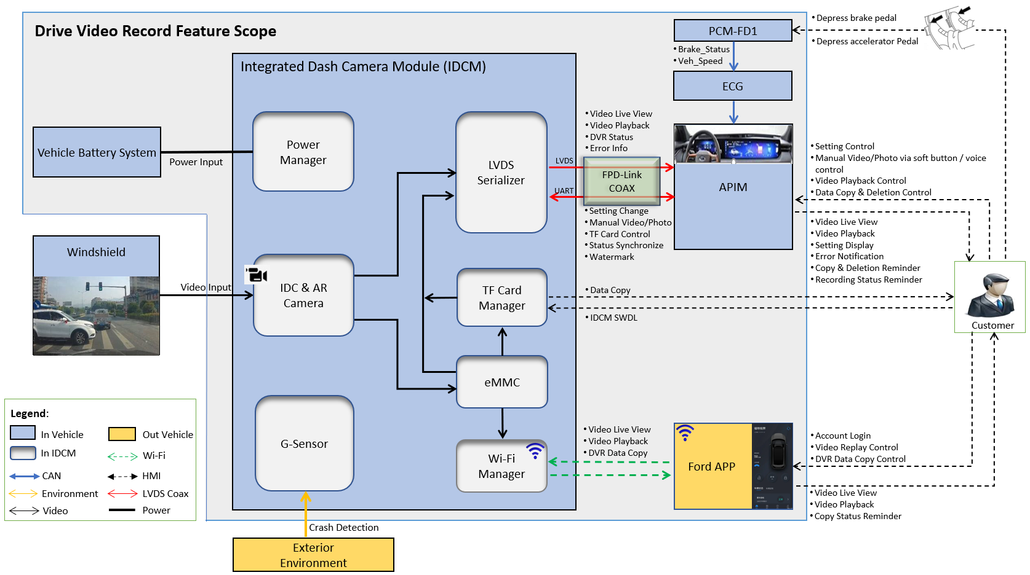

Figure 1-1 DVR System Diagram

## Terminology and Abbreviations

The following table lists terminologies that are used in this document along with a brief description.

| **Term** | **Description** |
| --- | --- |
| APIM | Auxiliary Protocol Interface Module |
| DVR | Drive Video Record |
| ECG | Enhanced Central Gateway |
| IDCM | Integrated Dash Camera |
| FNV X.X | Fully Networked Vehicle Architecture X.X |
| HMI | Human Machine Interface |
| POC | Powered Over Cable defined in TI FPD-Link protocol |

Table 1-1 Terminology and Abbreviation

# Architectural Design

## XXXXX-REQ-xxxxxx/A-DVR User

People who are using DVR functions via DVROnboardClient, DVROffboardClient and DVR server, include video play, data copy and DVR setting, etc.

## XXXXX-REQ-xxxxxx/A-DVR Onboard Client

The DVR Onboard Client (DVROnboardClient) is located inside vehicle, responsible for providing in vehicle HMI to DVR user for functions include video live view, playback, DVR setting, vehicle data collection and TF copy/deletion, etc.

## XXXXX-REQ-xxxxxx/A-DVR Offboard Client

The DVR Offboard Client (DVROffboardClient) is located out of vehicle, responsible for providing APP HMI to the user for live view, video playback, and data download, etc. APP in DVROffboardClient may include FordPass, LinclonWay and Mach-E.

## XXXXX-REQ-xxxxxx/A-DVR server

The DVR Server (DVRServer) is located inside vehicle, responsible for video recording/saving, collision detection and processing DVR user’s request from DVROnboardClient or DVROffboardClient.

## Physical Mapping of Classes

The table below shows an example of how the logical classes that make up the DVR feature may be mapped into physical modules.

|  |  |
| --- | --- |
| **Logical Class** | **Physical Module (ECU)** |
| DVROnboardClient | APIM -- Accessory Protocol Interface Module |
| DVROffboardClient | Smart Phone |
| DVRServer | IDCM -- Integrated Dash Camera Module |

Table 2-1 Physical Mapping

## Signal Mapping

The signals mentioned throughout this document shall refer to the signal’s logical name. The logical names shall be mapped to their actual signal names, all actual signals in this document are defined in <Drive Video Record UART Protocol>.

## DVRServer Interface

DVROnboardClient and DVRServer communicates via UART over FPD-Link, the hardware relays on a LVDS cable, all RX and TX interface is defined in <Drive Video Record UART Protocol>.

# General Requirements

## XXXXX-REQ-xxxxxx/A-Power Mode Design

DVR system shall support below power modes handled by DVRServer:

|  |  |  |  |  |  |
| --- | --- | --- | --- | --- | --- |
| **Control Factors** | | | | **Output** | |
| **POC1 status** | **Load**  **Shed5** | **Monitor**  **Timer2** | **Monitor**  **Counter3** | **DVR**  **Power Mode** | **DVR**  **Function** |
| On | / | / | / | Full Power Mode | All function |
| Off | N | < Timer Threshold | < Counter Threshold | Standby Mode4 | Only vehicle monitor |
| Off | N | >= Timer Threshold | >= Counter Threshold | Sleep Mode | No function |
| Off | Y | / | / |

Table 3-1 DVR System Power Mode

#1 -- POC (Power Over Cable) is HW signal provided by DVROnboardClient to DVRServer:

* POC = On, when DVROnboardClient is not in <IVI sleep mode>.
* POC = Off, when DVROnboardClient is in <IVI sleep mode>.

#2 -- Monitor Timer is DVRServer internal clock for KOL protection, the default threshold is 5 days. The Monitor Timer should be reset whenever DVR leaves standby mode, and could be configurable via DVROnboardClient CAN diagnostic.

#3 -- Monitor Counter is DVRServer internal counter for KOL protection, which defined as video numbers captured during standby mode, the default threshold is 10. The Monitor Counter should be reset whenever DVR leaves standby mode, and could be configurable via DVROnboardClient CAN diagnostic.

#4 -- Standby Mode is an optional status, DVRUser could disable vehicle monitor function in DVROnboardClient setting page.

#5 -- Whenever DVROnboardClient goes to <IVI sleep mode> due to load shed triggered or vehicle battery SoC protection happening, it should cascade this information to DVRServer via UART message before POC changes to Off ,and DVRServer should jump to Sleep Mode directly for the next time POC goes to Off.

### Full Power Mode

*When:*

*POC == On*

DVR should be in full power mode, and all functions should be available.

### Standby Mode

*When:*

*(POC == Off) && (Monitor Timer < Timer Threshold ) && (Monitor Counter < Counter Threshold) && (Load Shed == N)*

DVR will be in standby mode, only vehicle monitor function defined in Section 4.6 should be available.

### Sleep Mode

*When:*

*(POC == Off) && (Load Shed == Y)*

*Or*

*(POC == Off) && (Load Shed == N) && ((Monitor Timer >= Timer Threshold) || (Monitor Counter >= Counter Threshold))*

DVR should go to sleep mode, all functions should be disabled.

### Other Special Vehicle Mode

*When:*

*Vehicle lifecycle is in ~~Factory mode or~~ Transport mode or Critical Battery mode*

DVROnboardClient should set POC to Off, and DVR should go to sleep mode, all functions should be disabled.

### Power Mode Switch

Power mode switch state machine if no IVI load shed happens:

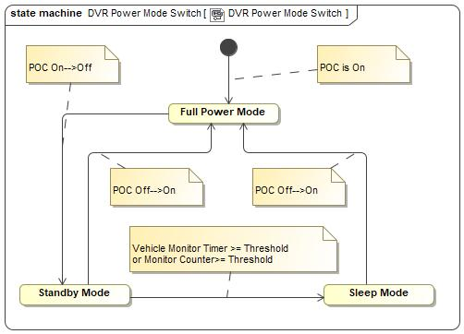

Figure 3-1.1 DVR Power Mode State Machine

Power mode timing control if no IVI load shed happens:

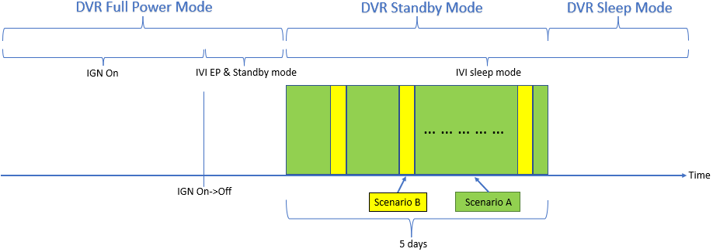

Figure 3-1.2 DVR Power Mode Description

* Scenario A: No collision is detected by DVRServer, DVRServer will keep in lowest power consumption.

* Scenario B: Vehicle collision is detected, DVRServer is waked up by internal G-Sensor, this status will continue 45s by default and could be changed via DVR setting. At the same time, scenario B could only happen less than 10 times to avoid battery drain.

## XXXXX-REQ-xxxxxx/A-Preconditions of Recording

DVR shall only start recording when internal (eMMC) or external (TF Card) memory device is available, if memory device is not available or broken, error reminder should be sent to DVRUser.

## XXXXX-REQ- xxxxxx /A-AR Camera Integration

The camera in DVRServer will also serve for AR Navigation or AR HUD feature, the format of the video captured by this camera should also meet the requirement of AR, video should be sent form DVRServer to DVROnboardClient via LVDS.

Specially, when DVROnboardClient HMI is in video/photo playback list page or replaying, AR feature will not be supported.

## XXXXX-REQ- xxxxxx /A-Legal Regulation

The DVR system should meet <GB/T 38892-2020> requirement, the validation and feature sign-off should follow GB/T definition.

## XXXXX-REQ- xxxxxx /A-DVR System Communication

DVRServer should support two-way communication with DVROnboardClient via UART over FPD-Link, the HW connection is LVDS cable.

DVRServer should also support two-way communication with DVROffboardClient via Wi-Fi connection, DVRServer will work as a Wi-Fi hotspot, DVROffboardClient will work as Wi-Fi station.

## XXXXX-REQ- xxxxxx /A-EOL Requirement

1. All video or photo captured during EOL at Ford plant should be deleted via DVROnboardClient HMI before vehicle goes to dealer side.
2. There should be an on demand self-test DTC in DVROnboardClient to confirm if any DVRServer system error existing at Ford plant EOL.

## XXXXX-REQ- xxxxxx /A-Vehicle Data Collection

DVROnboardClient should collect vehicle data from CAN bus, and share the data to DVRServer to support video watermark and collision detection, there are two kinds of vehicle data: mandatory data and optional data:

* Mandatory data is defined by GB/T 38892.
* Optional data is defined by Ford.

|  |  |  |  |  |
| --- | --- | --- | --- | --- |
| **Name** | **RX Mode** | **Interval (ms)** | **Latency** | **Comments** |
| **Mandatory Data** | | | | |
| VIN | Event | / | / | Support watermark |
| System Date & Time | Periodic | / | / |
| **Optional Data** | | | | |
| Brake status | Event + Periodic | 200 | <=200 | Support collision detection |
| Vehicle Speed | Periodic | 20 | <=100 | Support watermark and collision detection |
| Cornering Lamp Status | Periodic | 500 | <=500 | Support watermark |
| Seat belt status | Periodic | 500 | <=500 |
| Gear position | Periodic | 500 | <=500 |

Table 3-2 DVR Vehicle Data Collection Definition

# Functional Definition

## XXXXX-FUN-REQ-xxxxxx/A-Enable/Disable Normal Video Record

### Requirements

Normal Video (aka cycle video) Record function should be disabled before user enable normal video record option through DVR setting.

#### XXXXX-REQ-xxxxxx/A-First Time Usage

A popup message should be shown on DVROnboardClient when the first-time ignition on, ask customer to choose if enable DVR video record function, if the feedback is YES, normal video record defined in 4.2.2.1 should be enabled.

#### XXXXX-REQ-xxxxxx/A-Normal Video Record Enable/Disable Switch

DVR could be switched between Enabled and Disabled via the DVR setting menu on DVROnboardClient, DVRServer and DVROnboardClient shall save the enable/disable setting result in memory, and ask customer if keep disabled when next 3 times ignition on, DVROnboardClient shall provide a reminder icon (Recording Status Icon) to show normal video recording enable or disable status.

The status of normal video recording should not impact video capture for AR Navigation feature, for example, Video recording is disabled and AR feature is enabled on DVROnboardClient, DVRServer shall still capture the video and send it to DVROnboardClient, however the normal video will not be captured and saved.

When DVRUser login Ford account successfully on DVROnboardClient and normal video recording is disabled, DVROnboardClient should try to ask customer to open recording again.

### Use Cases

#### XXXXX-UC-REQ-xxxxxx/A-User enable/disable normal video record via DVROnboardClient successfully

|  |  |
| --- | --- |
| **Actors** | User, DVRServer, DVROnboardClient |
| **Pre-conditions** | DVRServer is at full power mode  DVROnboardClient HMI is active  DVRServer memory device is available |
| **Scenario Description** | User enters DVR setting menu on DVROnboardClient  User selects to enable/disable video record |
| **Post-conditions** | Video record switches to enabled/disabled successfully  If enable:   * Video record should be available * The Recording Status Icon on DVROnboardClient HMI main page should be Green   if disable:   * Video record should be disabled * The Recording Status Icon on DVROnboardClient HMI main page should be Grey   DVR Server should synchronize the status to DVROffboardClient |
| **List of Exception Use Cases** | User enable/disable normal video record via DVROnboardClient failed. |
| **Interfaces** | UART, Wi-Fi, HMI |

Table 4-1 Enable/Disable Normal Video Record Successfully

#### XXXXX-UC-REQ-xxxxxx/A-User enable/disable normal video record via DVROnboardClient failed

|  |  |
| --- | --- |
| **Actors** | User, DVRServer, DVROnboardClient |
| **Pre-conditions** | DVRServer is at full power mode  DVROnboardClient HMI is active  DVRServer memory device is available |
| **Scenario Description** | User enters DVR menu on DVROnboardClient  User selects to enable/disable video record |
| **Post-conditions** | Failed to switch normal video record:   * An error message is displayed to the user * The Recording Status Icon on DVROnboardClient HMI main page should keep no change |
| **List of Exception Use Cases** |  |
| **Interfaces** | UART, HMI |

Table 4-2 Enable/Disable Normal Video Record Failed

### White Box View

#### Activity Diagrams

##### XXXXX-ACT-REQ-xxxxxx/A-User enable/disable normal video record via DVROnboardClient

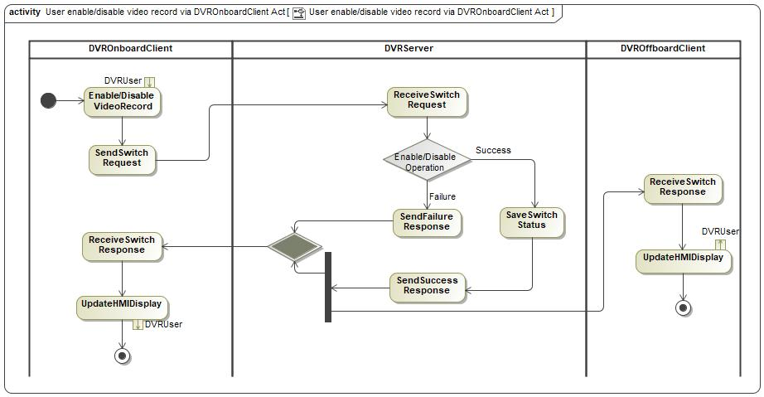

Figure 4-1 Enable/Disable Normal Video Record via DVROnboardClient

#### Sequence Diagrams

##### XXXXX-SD-REQ-xxxxxx/A-User enable/disable normal video record via DVROnboardClient

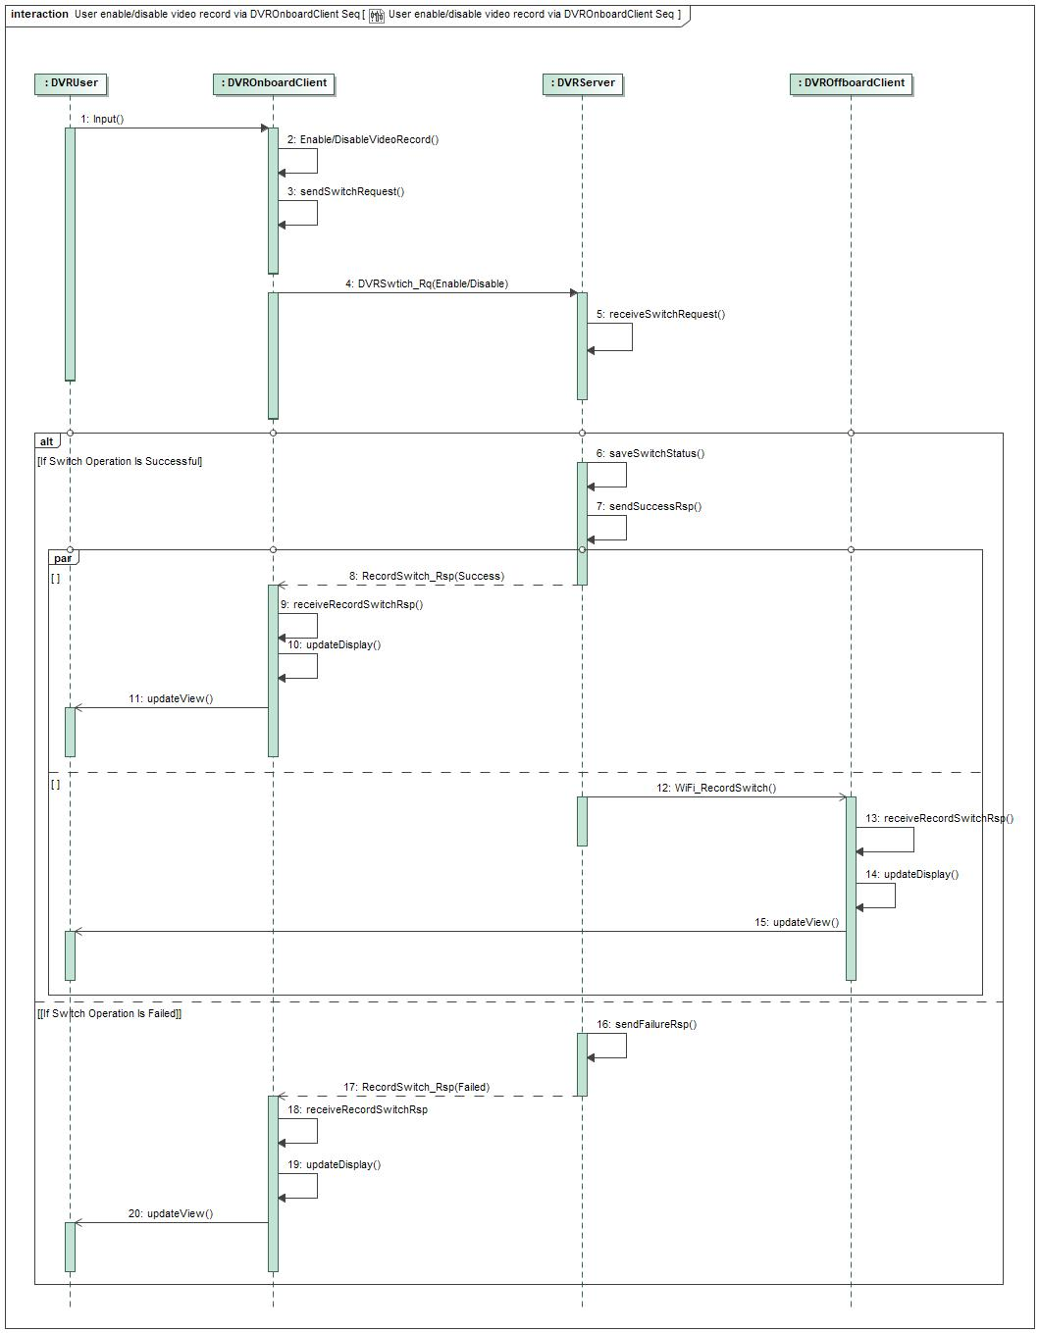

Figure 4-2 Enable/Disable Normal Video Record via DVROnboardClient

## XXXXX-FUN-REQ-xxxxxx/A-Video/Photo Data Record and Save

### Requirements

DVRServer should have ability to save video/photo into local memory or external memory.

#### XXXXX-REQ-xxxxx/A-Data Saving Location

There are four kinds of data could be recorded into DVRServer local memory (eMMC).

|  |  |  |  |  |
| --- | --- | --- | --- | --- |
| File Type | Resolution | Format | Default Save Location | Data Size |
| Normal Video | 1080P | MP4 | “Normal Data” folder in eMMC | At least support 4 hours video |
| Emergency Video | 1080P | MP4 | “Key Data” folder in eMMC | At least support 1 hour video |
| Manual Video | 1080P | MP4 | At least support 0.5 hours video |
| Manual Photo | 1920*1080 | JPG | At least support 400 pics photo |

Table 4-3 DVR File System

DVRServer should follow FIFO design to make sure the newest data could cover the oldest one when memory is full, all videos should be encoded by H.264 and save as MP4 format, and photos should be saved in JPG format. File system in eMMC should include:

1. “Normal Data” folder
2. “Key Data” folder

File system in TF card should have same two folders, DVRServer should support 8~128GB TF card.

There are three file storage location:

1. **eMMC**: All data must be saved into an DVRServer internal eMMC, the size of eMMC should support at least 4 hours video data storage according to GB/T 38892 requirement.
2. **TF Card**: If User inserts TF card into DVRServer, all data could be saved into TF card manually via DVROnboardClient.
3. **Smart Phone**: User could copy files to smart phone local file system via Wi-Fi connection between DVROffboardClient and DVRServer.

#### XXXXX-REQ-xxxxx/A-Data Naming

All data should be saved with below naming rule:

1. Normal Video: NOR-<Year-Month-Day Hour-Minute-Second>.mp4
2. Emergency Video: EVT-<Year-Month-Day Hour-Minute-Second>.mp4
3. Manual Video: MAN-<Year-Month-Day Hour-Minute-Second>.mp4
4. Manual Photo: PHO-<Year-Month-Day Hour-Minute-Second>.jpg

#### XXXXX-REQ-xxxxxx/A-Normal Video Record

Once normal video record is enabled and memory device is available, DVRServer should keep normal video recording automatically, according to GB/T 38892, all normal video must be saved into eMMC without modification. The default normal video duration is 3 minutes and should be saved into “Normal Data” folder.

#### XXXXX-REQ-xxxxxx/A-Emergency Video Record

DVRServer should has the ability to detect the vehicle collision via internal G-Sensor detection, then trigger emergency video record, video should be saved into “Key Data” folder.

If normal video record is enabled, emergency video should contain 15 seconds before and 30 seconds after collision detected. If normal video record is disabled, emergency video should only contain 30 seconds after collision detected.

*The 30 seconds is a default value which could be changed through DVR setting.

#### XXXXX-REQ-xxxxxx/A-Manual Video/Photo Record

There are several ways to trigger manual video record:

1. Soft button on DVROnboardClient
2. Voice control via DVROnboardClient if available
3. Gesture control via DVROnboardClient if available (optional)
4. Hard button on steering wheel (optional)

Manual video should be saved into “Key Data” folder. If normal video record is enabled, manual video should contain 15 seconds before and max to 45 seconds after manual video triggered. If normal video record is disabled, manual video should only contain max to 45 seconds after manual video triggered, customer could stop manual recording at any time before video capture end.

There are five ways to trigger manual photo record:

1. Soft button on DVROnboardClient menu
2. Voice control via DVROnboardClient if available
3. Gesture control via DVROnboardClient if available (optional)
4. Hard button on steering wheel (optional)
5. Screenshot button when video play back*

Screenshot during video play will help to save the key frame of a video.

#### XXXXX-REQ-xxxxxx/A-Manual Recording Voice Control Command List

Below is the voice control list to support trigger manual video and photo request:

|  |  |  |  |  |
| --- | --- | --- | --- | --- |
| **ID** | **Voice Command** | **Key Words** | **IVI TTS Feedback** | **HMI UE/UI Feedback** |
| **1** | Enter DVR APP | Open DVR | Already enter DVR | Enter DVR HMI main page |
| **2** | Leave DVR APP | Close DVR | Already leave DVR | Leave DVR HMI main page |
| **3** | Manual Photo | I’d like to take a photo | Photo successfully or failed | NA. |
| **4** | Start Manual Video | I’d like to take a video | Start recording | Display the status of recording |
| **5** | Stop Manual Video | Stop taking video | Pls start recording firstly(if video record not started) or Video recording stopped | Display the result of recording |
| **6** | Other Potential Command | For example: play video X. | DVR not support currently voice control | NA. |

Table 4-4 Voice Control Command List

#### XXXXX-REQ-xxxxxx/A- Vehicle Information Watermark

DVRServer should have the ability to overlay the necessary vehicle and DVR work status information on the saved video, watermark information is defined in section 3.7, All DVR video should support watermark.

Below is an example of water mark:

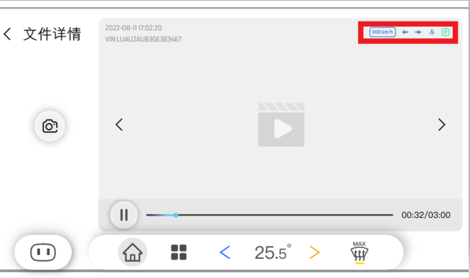

Figure 4-3 Video Watermark Example

### Use Cases

#### XXXXX-UC-REQ-xxxxxx/A-Normal Video Record

|  |  |
| --- | --- |
| **Actors** | DVRServer |
| **Pre-conditions** | Video record is enabled  DVRServer is in full power mode  DVRServer memory device is available, and no error detected |
| **Scenario Description** | DVRServer continues to do video recording periodically |
| **Post-conditions** | Video should be saved into eMMC normal data folder with same naming rule |
| **List of Exception Use Cases** | Failed to Video/Photo Record |
| **Interfaces** |  |

Table 4-5 Normal Video Record

#### XXXXX-UC-REQ- xxxxxx/A-Emergency Video Record

|  |  |
| --- | --- |
| **Actors** | DVRServer, DVROnboardClient |
| **Pre-conditions** | Video record is enabled  DVRServer is in full power mode  DVRServer memory device is available, and no error detected  Vehicle collision event is detected by DVRServer |
| **Scenario Description** | DVRServer should trigger an emergency video recording |
| **Post-conditions** | The emergency video should be saved into key data folder with same naming rule  Notify user that a new emergency Video is captured through DVROnboardClient HMI. |
| **List of Exception Use Cases** | Failed to Video/Photo Record |
| **Interfaces** | UART, HMI |

Table 4-6 Emergency Video Record

#### XXXXX-UC-REQ- xxxxxx/A-Manual Video/Photo Record

|  |  |
| --- | --- |
| **Actors** | User, DVRServer, DVROnboardClient, DVROffboardClient |
| **Pre-conditions** | Video record is enabled  DVRServer is in full power mode  DVRServer memory device is available, and no error detected  Soft button or voice control or gesture control is triggered by user on DVROnboardClient or soft button is triggered by user on DVROffboardClient |
| **Scenario Description** | DVRServer should trigger a manual video recording |
| **Post-conditions** | The manual video/photo should be saved into key data folder with same naming rule  Notify user that a new manual video/photo is saved successfully |
| **List of Exception Use Cases** | Failed to Video/Photo Record |
| **Interfaces** | UART, Wi-Fi, HMI |

Table 4-7 Manual Video/Photo Record

#### XXXXX-UC-REQ- xxxxxx/A-Failed to Video/Photo Record

|  |  |
| --- | --- |
| **Actors** | User, DVRServer, DVROnboardClient, DVROffboardClient |
| **Pre-conditions** | Video record is enabled  DVRServer is in full power mode  When normal or emergency or manual video/photo record is triggered |
| **Scenario Description** | DVRServer detects there is an internal issue, includes memory(eMMC) broken, camera HW failure, etc. |
| **Post-conditions** | An error message should be displayed to user via DVROnboardClient HMI.  An error message should be displayed to user via DVROffboardClient HMI if Wi-Fi connection enabled.  Related error info should be saved |
| **List of Exception Use Cases** |  |
| **Interfaces** | UART, Wi-Fi, HMI |

Table 4-8 Video/Photo Record Failed

### White Box View

#### Activity Diagrams

##### XXXXX-ACT-REQ- xxxxxx/A-Normal Video Record

*DVROffboardClient related logic is optional, will not be supported on FNV2.1.

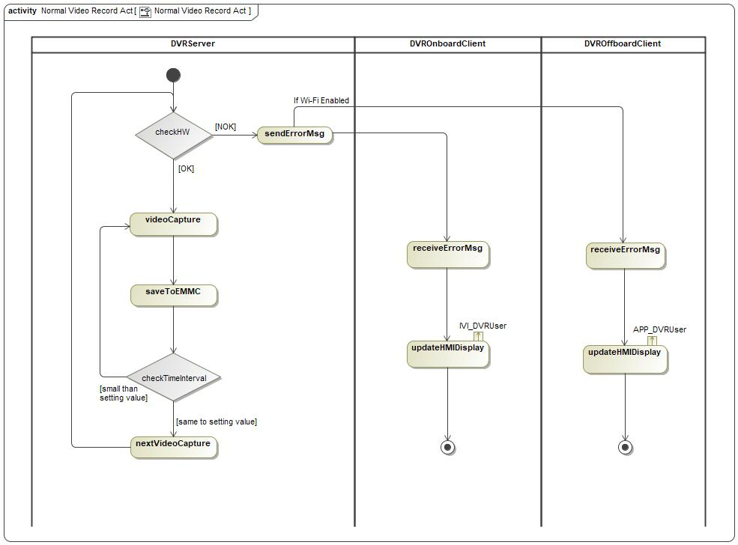

Figure 4-4 Normal Video Record

##### XXXXX-ACT-REQ- xxxxxx/A-Emergency Video Record

*DVROffboardClient related logic is optional, will not be supported on FNV2.1.

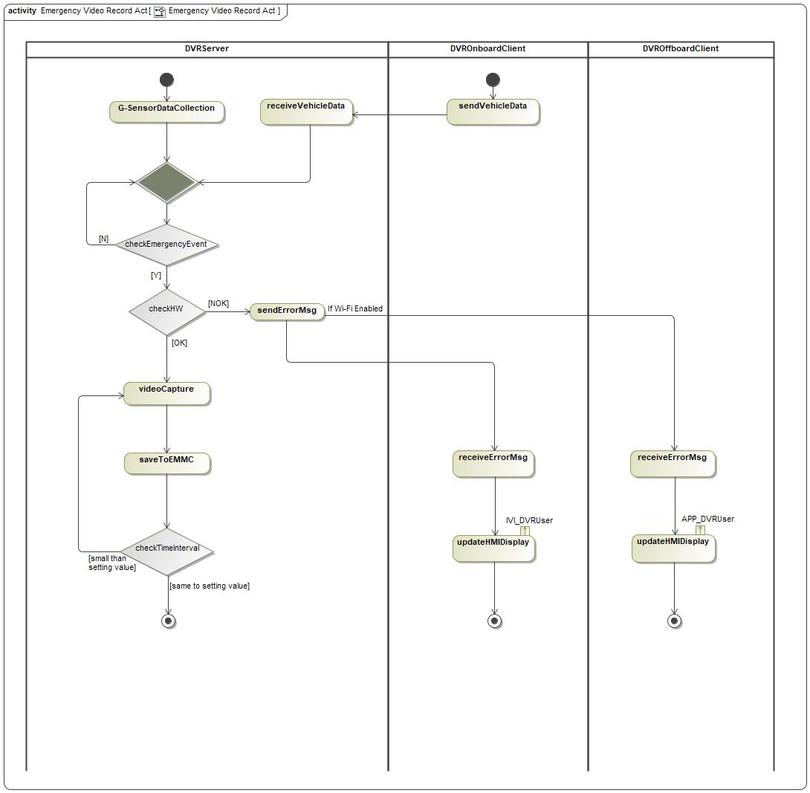

Figure 4-5 Emergency Video Record

##### XXXXX-ACT-REQ- xxxxxx/A-Manual Video or Photo Record

*DVROffboardClient related logic is optional, will not be supported on FNV2.1.

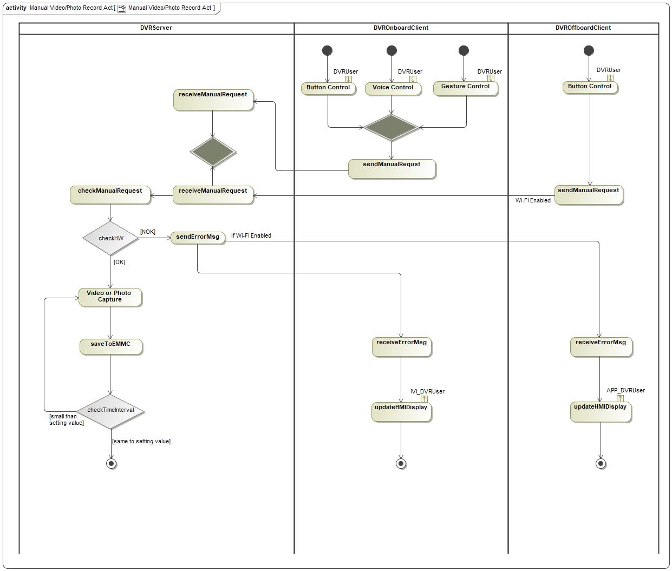

Figure 4-6 Manual Video Record

#### Sequence Diagrams

##### XXXXX-SD-REQ- xxxxxx/A-Normal Video Record

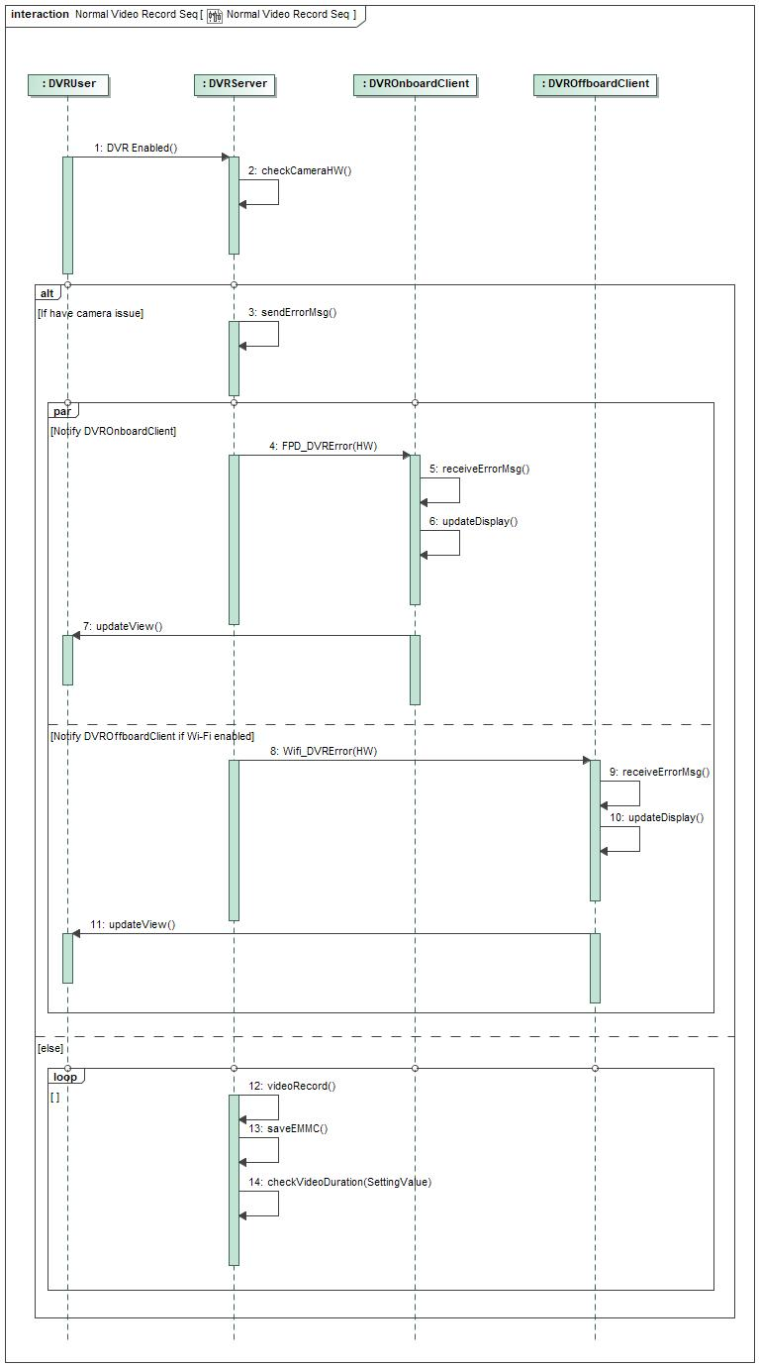

Figure 4-7 Normal Video Record

##### XXXXX-SD-REQ- xxxxxx/A-Emergency Video Record

*DVROffboardClient related logic is optional, will not be supported on FNV2.1.

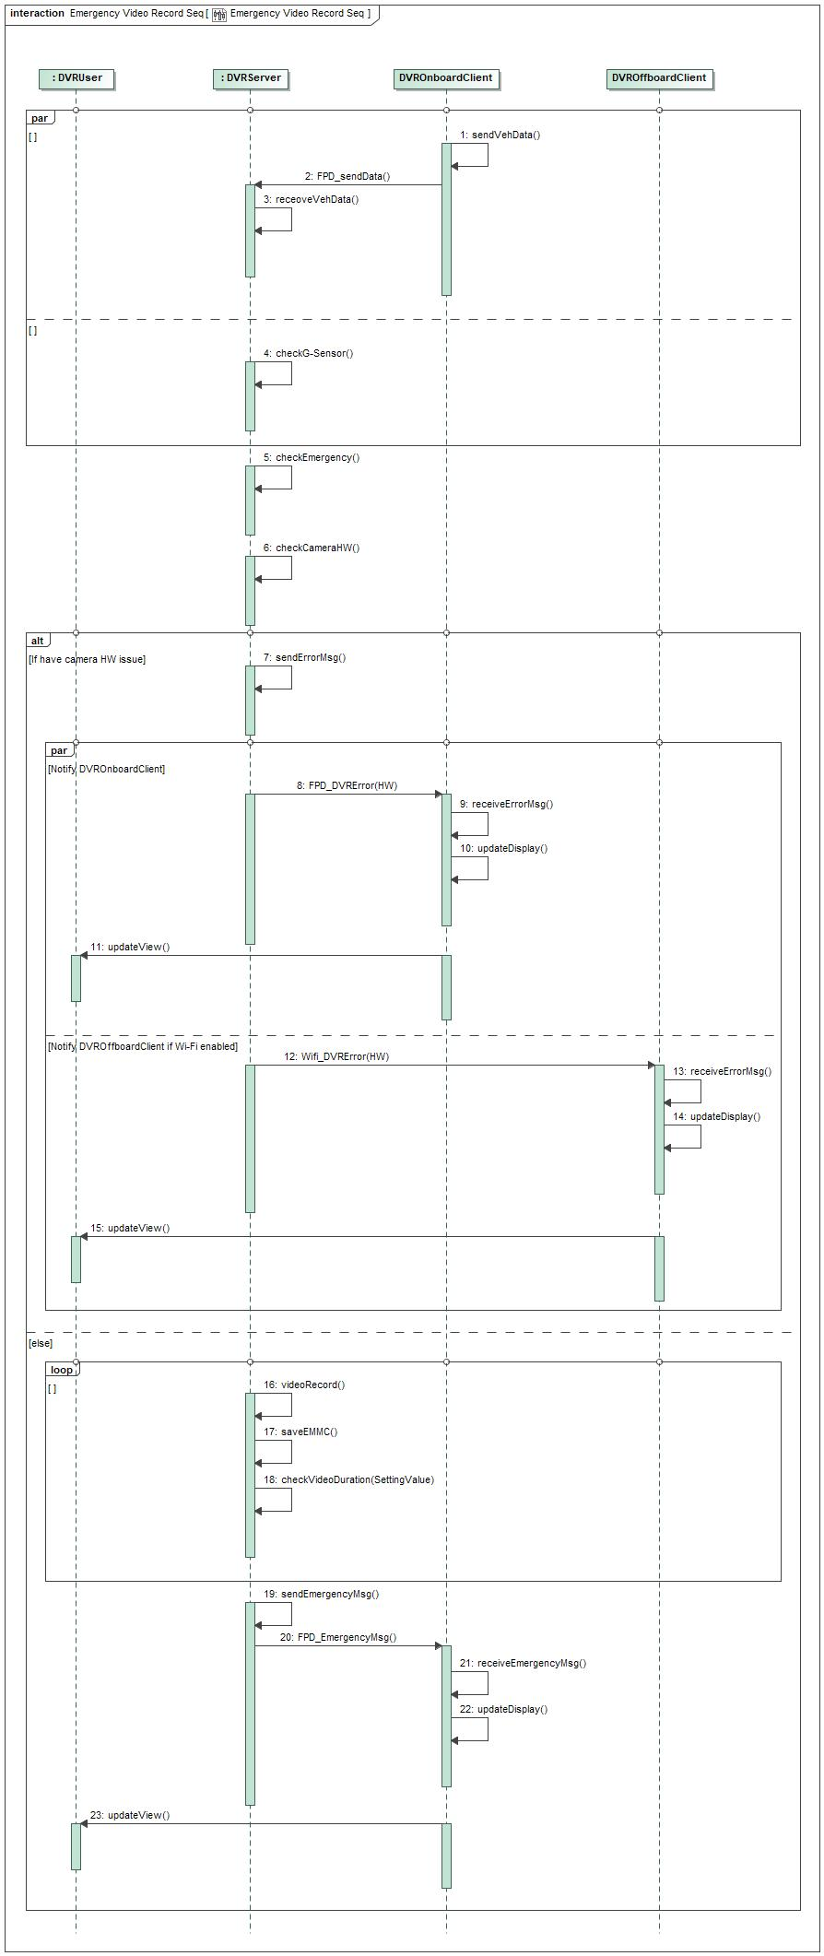

Figure 4-8 Emergency Video Record

##### XXXXX-SD-REQ- xxxxxx/A-Manual Video Record

*DVROffboardClient related logic is optional, will not be supported on FNV2.1.

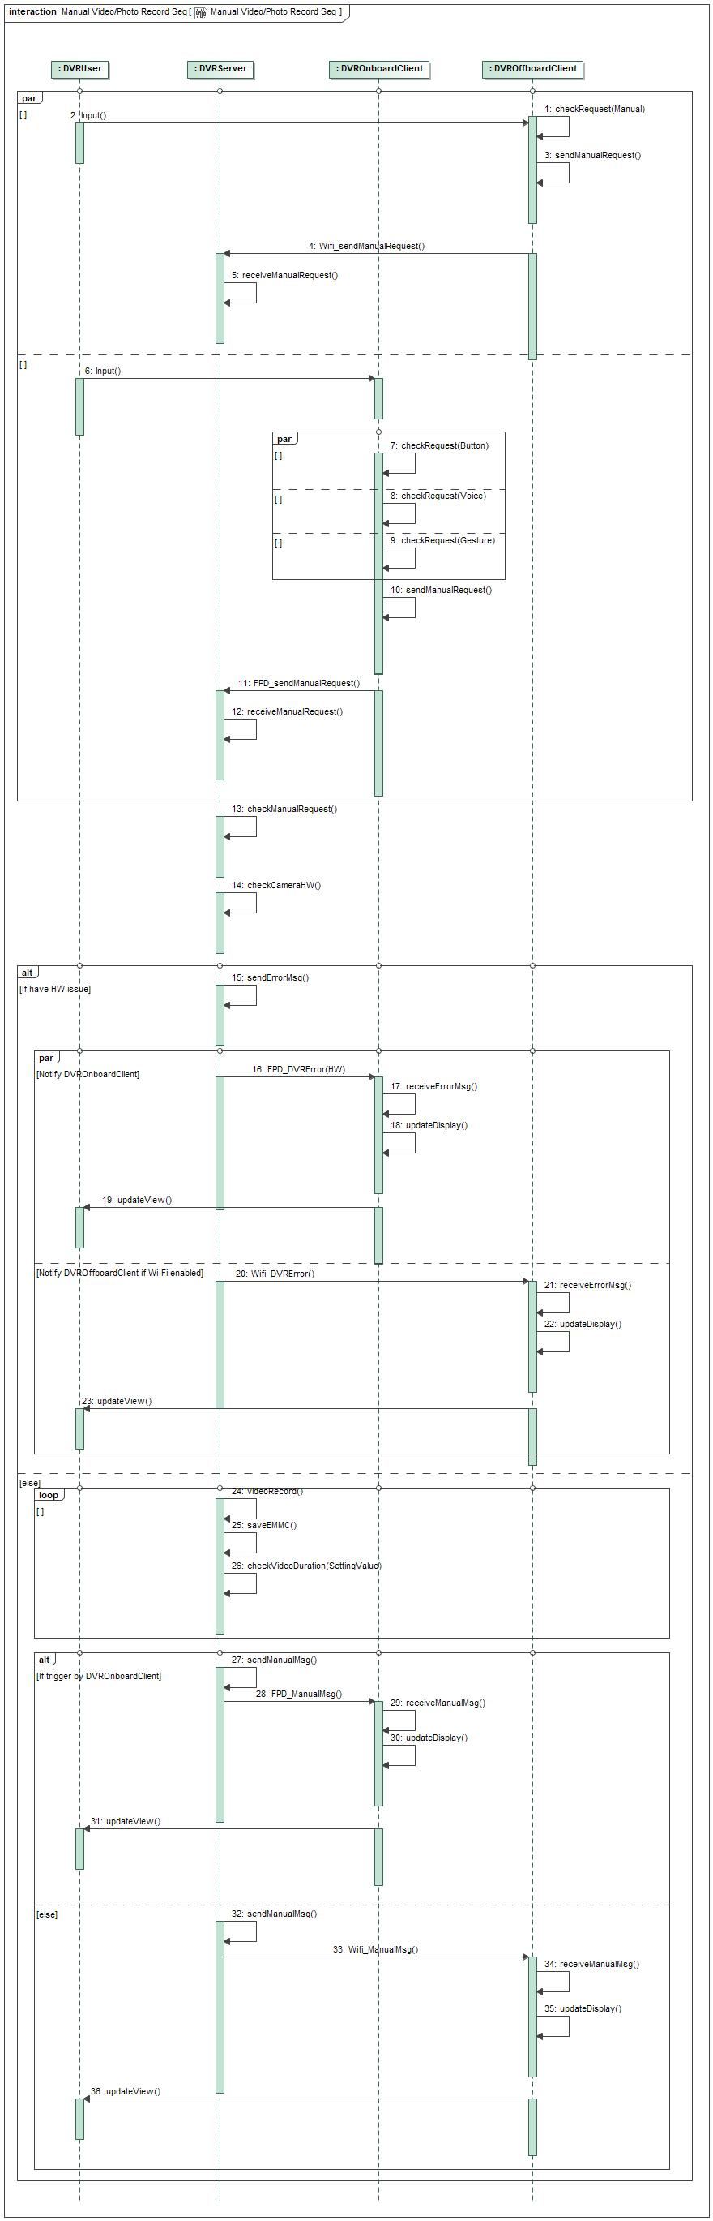

Figure 4-9 Manual Video Record

## XXXXX-FUN-REQ-xxxxxx/A-Video/Photo Display

### Requirements

DVROnboardClient and DVROffboardClient should provide video display HMI for DVR user.

#### XXXXX-REQ-xxxxxx/A-Video Liveview

DVR system shall support video live view for user to preview the video, liveview should be active once DVR user enters DVR main page on DVROnboardClient or DVROffboardClient.

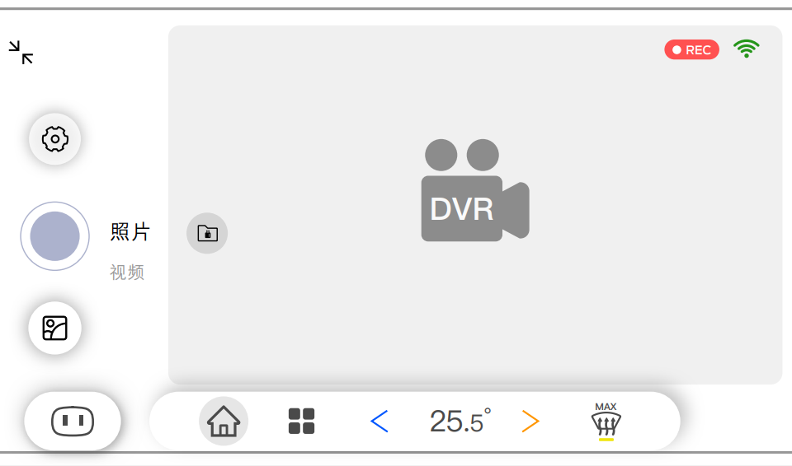

Figure 4-10 DVROnboardClient DVR Main Page

The delay between video is captured and displayed should less than 200ms, this requirement both apply for LVDS connection to DVROnboardClient and Wi-Fi connection to DVROffboardClient.

#### XXXXX-REQ-xxxxxx/A-Video/Photo Playback List

DVR system shall support video/photo playback function for user to easy replay the video/photo. When user enter Video/Photo playback sub-menu on DVROnboardClient or DVROffboardClient, video list should be shown for user to select, if one of the video is chosen, corresponding video should be played immediately:

1. The newest video should be highlight in the playback list.
2. All files should be sorted by date.
3. The totally video/photo number in one day should be displayed.

below is the HMI example on DVROnboardClient:

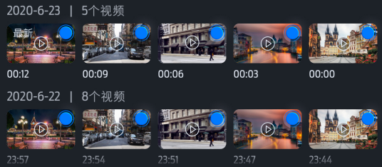

Figure 4-11 DVROnboardClient Video Playback List Page

When video playback function is active, AR HUD or AR Navigation function should be disabled in DVROnboardClient.

#### XXXXX-REQ-xxxxxx/A-Video/Photo Playback Control

Video playback only could be available when vehicle gear position is at “P”, DVRServer should decode data in EMMC or read data from TF card to show it on DVROnboardClient or DVROffboardClient, User could do start/stop/forward/backward operation on DVROnboardClient or DVROffboardClient. A progress bar is preferred to support video forward and backward easily.

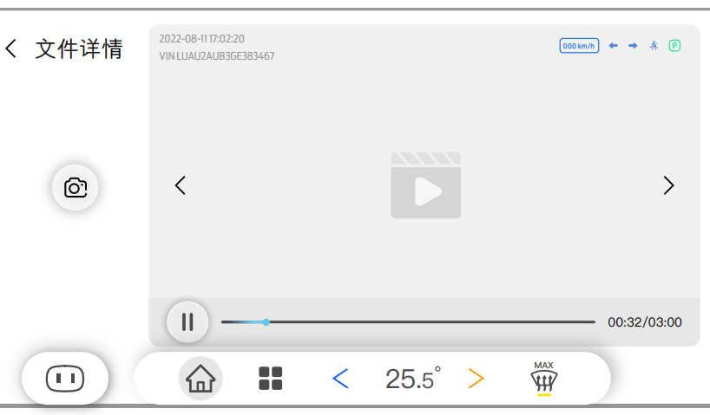

Figure 4-12 DVROnboardClient DVR Playback Control Page

### Use Cases

#### XXXXX-UC-REQ-xxxxxx/A-Video Liveview on DVROnboardClient or DVROffboardClient

|  |  |
| --- | --- |
| **Actors** | User, DVRServer, DVROnboardClient, DVROffboardClient |
| **Pre-conditions** | DVR is in full power mode |
| **Scenario Description** | User enters DVR main page menu on DVROnboardClient or DVROffboardClient |
| **Post-conditions** | Live view is displayed on DVROnboardClient or DVROffboardClient |
| **List of Exception Use Cases** |  |
| **Interfaces** | HMI, LVDS, Wi-Fi |

Table 4-9 Video Live View Use Case

#### XXXXX-UC-REQ-422181/A-Video/Photo Playback on DVROnboardClient or DVROffboardClient

|  |  |
| --- | --- |
| **Actors** | User, DVRServer, DVROnboardClient, DVROffboardClient |
| **Pre-conditions** | DVR is in full power mode  No memory issue is detected  Vehicle gear position is at “P” |
| **Scenario Description** | User enters one of DVR video/photo playback folder:   * Local(eMMC) “Normal Data” folder * Local(eMMC) “Key Data” folder * TF card “Key Data” folder   And one of the video or photo is chosen. |
| **Post-conditions** | Video or photo is displayed on DVROnboardClient or DVROffboardClient |
| **List of Exception Use Cases** |  |
| **Interfaces** | HMI, LVDS, Wi-Fi |

Table 4-10 Video Playback List Use Case

#### XXXXX-UC-REQ-422182/A-Video Playback Control

|  |  |
| --- | --- |
| **Actors** | User, DVRServer, DVROnboardClient, DVROffboardClient |
| **Pre-conditions** | Video playback is active on DVROnboardClient or DVROffboardClient |
| **Scenario Description** | User selects video start/stop/forward/backward |
| **Post-conditions** | One of the operations is performed by DVRServer according to user selection: start/stop/forward/backward. |
| **List of Exception Use Cases** |  |
| **Interfaces** | HMI, LVDS, Wi-Fi |

Table 4-11 Video Playback Control Use Case

#### XXXXX-UC-REQ-422182/A- DVROnboardClient Video Playback Page Display Timeout

|  |  |
| --- | --- |
| **Actors** | User, DVRServer, DVROnboardClient |
| **Pre-conditions** | HMI keep in video playback list page  Or  Video playback is happening |
| **Scenario Description** | HMI keeps in video playback list page more than 1 minute  Or  User stops video play and keep more than 1 minute |
| **Post-conditions** | Should go back to DVR live view main page. |
| **List of Exception Use Cases** |  |
| **Interfaces** | HMI, LVDS, Wi-Fi |

Table 4-12 Video Playback Timeout Use Case

### White Box View

#### Activity Diagrams

##### XXXXX-ACT-REQ-xxxxxx/A-Video Liveview

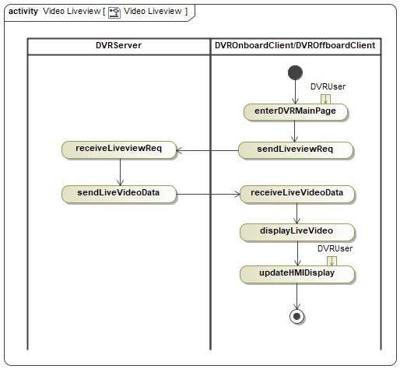

Figure 4-13 Video Liveview

##### XXXXX-ACT-REQ-xxxxxx/A-Video Playback

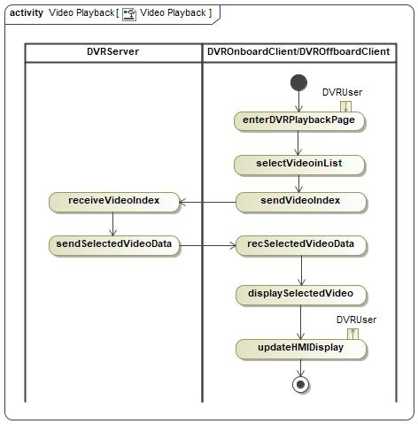

Figure 4-14 Video Playback List

##### XXXXX-ACT-REQ-xxxxxx/A-Video Playback Start/Stop/Forward/Backward Control

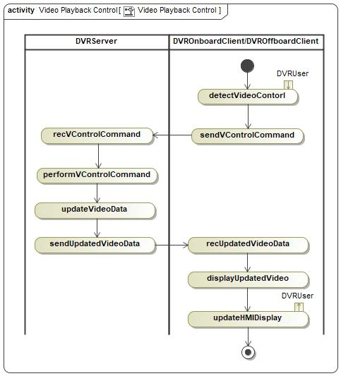

Figure 4-15 Video Playback Control

##### XXXXX-ACT-REQ-xxxxxx/A- DVROnboardClient Video Playback Page Display Timeout

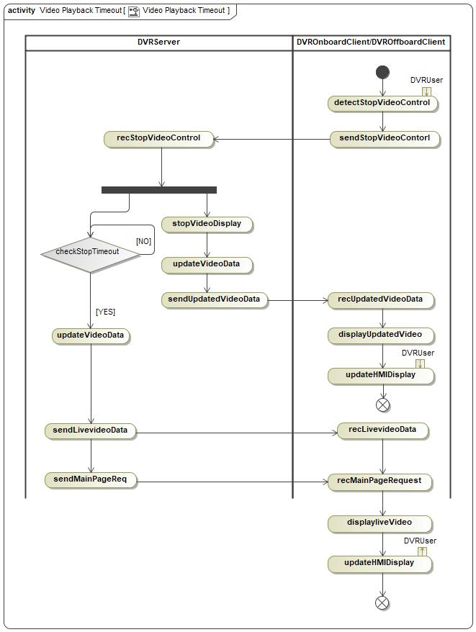

Figure 4-16 Video Playback Timeout

## XXXXX-FUN-REQ-xxxxxx/A-DVR Setting & Information Display

### Requirements

All DVR setting and necessary information should be provided to user via DVROnboardClient.

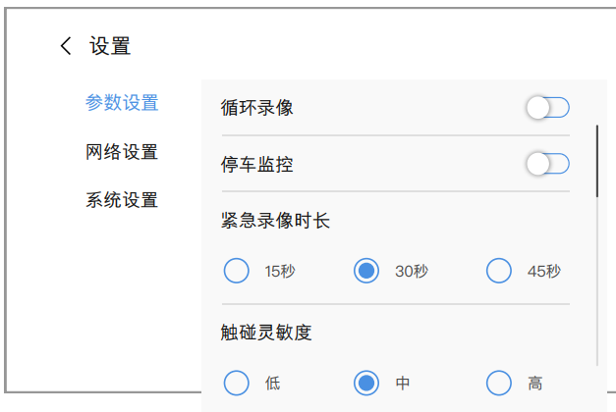

Figure 4-17 DVR Setting Example

#### XXXXX-REQ-xxxxxx/A-DVR Setting Content

The DVROnboardClient and DVROffboardClient(Optional) should provide below setting option to DVR user:

|  |  |  |  |  |  |
| --- | --- | --- | --- | --- | --- |
| ID | Classification | Setting Name | Optional Value | Default Value | Function Description |
| 1 | Record Setting | Normal Video Record | Enable/Disable | Disable | Choose if normal video record enabled |
| 2 | Vehicle Monitor Switch | Enable/Disable | Disable | Enable or Disable vehicle monitor function |
| 3 | Emergency Video Duration | 15 / 30 / 45 seconds | 30 | Choose the duration of emergency video and vehicle monitor video |
| 4 | Collision Detection Sensitivity | High / Middle / Low | Middle | Choose the sensitivity of the G-Sensor in DVRServer |
| 5 | Connection Setting | Wi-Fi Hotspot Switch | Enable/Disable | Disable | Enable or Disable Wi-Fi hotspot function |
| 6 | DVR Wi-Fi SSID | SSID | / | For user to modify the SSID of the DVR Wi-Fi connection |
| 7 | DVR Wi-Fi Password | Password | / | For user to modify the password of the DVR Wi-Fi connection |
| 8 | System Setting | Restore to Factory Defaults Setting | Yes/No | No | Allow user to rollback all the setting value to factory defaults |
| 9 | Format TF Card | Yes/No | No | Erase all TF data |

Table 4-13 DVR Setting Summary

#### XXXXX-REQ-xxxxxx/A-DVR Information Display

The DVROnboardClient should display below information to DVR user:

|  |  |  |  |  |
| --- | --- | --- | --- | --- |
| ID | Classification | Information Name | Example Value | Description |
| 1 | DVR Information | DVR Firmware Version | 3.6.9.4v | DVRServer SW version |
| 2 | DVR Internal Memory Status | 70% | EMMC usage status |
| 3 | TF Card Memory Status | 16% | TF card usage status |

Table 4-14 DVR Information Display Summary

#### XXXXX-REQ- xxxxxx /A-Setting Change when Recording is Active

If recording is already active and a setting change (Resolution, Recording time, etc.) occurs through DVROnboardClient/ DVROffboardClient, DVROnboardClient/ DVROffboardClient shall send StopRecording_Rq to DVRServer to end the current recording, and send StartRecording_Rq to DVRServer to start a new recording once the new settings take effect.

#### XXXXX-REQ- xxxxxx /A-Settings Storage

The IDCMServer and DVROnboardClient shall be capable to store settings option from DVRUser.

### Use Cases

#### XXXXX-UC-REQ-xxxxxx/A-Modify DVR Setting via DVROnboardClient

|  |  |
| --- | --- |
| **Actors** | User, DVRServer, DVROnboardClient, DVROffboardClient |
| **Pre-conditions** | DVRServer is at full power mode  DVROnboardClient HMI is active |
| **Scenario Description** | User changes the setting value via DVROnboardClient or DVROffboardClient menu. |
| **Post-conditions** | DVRServer accepts the new setting value and send the same value back to DVROnboardClient and DVROffboardClient to update HMI display. |
| **List of Exception Use Cases** | Failed to Modify DVR setting or read DVR Information |
| **Interfaces** | HMI, UART, Wi-Fi |

Table 4-15 DVR Setting Change

#### XXXXX-UC-REQ-xxxxxx/A-DVR Information Update via DVROnboardClient or DVROffboardClient

|  |  |
| --- | --- |
| **Actors** | User, DVRServer, DVROnboardClient, DVROffboardClient |
| **Pre-conditions** | DVRServer is at full power mode  DVROnboardClient HMI is active |
| **Scenario Description** | User tries to read the DVR information via DVROnboardClient or DVROffboardClient menu |
| **Post-conditions** | DVRServer sends the request information to DVROnboardClient or DVROffboardClient to display |
| **List of Exception Use Cases** | Failed to Modify DVR setting or read DVR Information |
| **Interfaces** | HMI, UART, Wi-Fi |

Table 4-16 DVR Information Update

#### XXXXX-UC-REQ-xxxxxx/A-Failed to Modify DVR setting or read DVR Information

|  |  |
| --- | --- |
| **Actors** | User, DVRServer, DVROnboardClient, DVROffboardClient |
| **Pre-conditions** | DVRServer is at full power mode  DVROnboardClient HMI is active  DVRServer memory device is available |
| **Scenario Description** | User tries to modify DVR setting or ready DVR system information via DVROnboardClient or DVROffboardClient menu |
| **Post-conditions** | DVRServer could not feedback right setting value or information  DVROnboardClient or DVROffboardClient pops up error message to User “Failed to Set DVR” or “Failed to Read DVR Information” |
| **List of Exception Use Cases** |  |
| **Interfaces** | HMI, UART, Wi-Fi |

Table 4-17 DVR Setting and Information Update Failed

### White Box View

#### Activity Diagrams

##### XXXXX-ACT-REQ-xxxxxx/A- Modify DVR Setting via DVROnboardClient

*DVROffboardClient related logic is optional, will not be supported on FNV2.1.

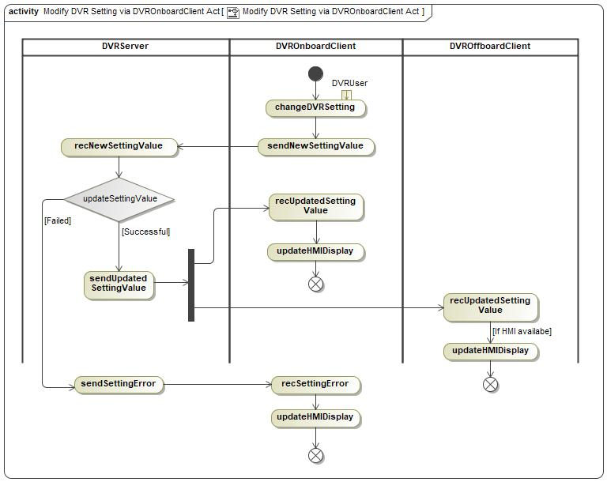

Figure 4-18 DVR Setting

##### XXXXX-ACT-REQ-xxxxxx/A- DVR Information Update via DVROnboardClient

*DVROffboardClient related logic is optional, will not be supported on FNV2.1.

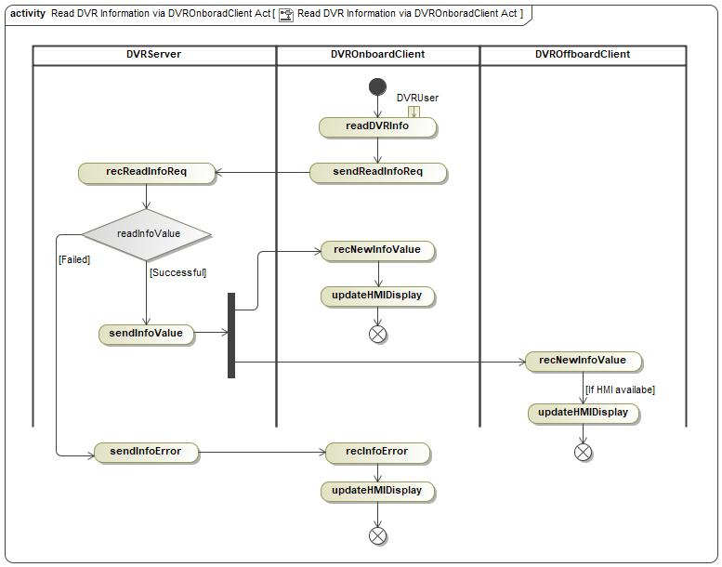

Figure 4-19 DVR Information Update

## XXXXX-FUN-REQ-xxxxxx/A-Data Copy and Deletion

### Requirements

All video/photo data must be saved into eMMC in DVRServer, DVR system support below use cases:

1. Copy data from eMMC to TF card via DVROnboardClient.
2. Copy data from eMMC to smartphone via DVROffboardClient.
3. Delete data in TF card via DVROnboardClient.

Data in eMMC could not be deleted according to GB/T 38892-2020 section 5.3.4.1.

#### XXXXX-REQ-xxxxxx/A- Precondition of Data Copy and Deletion

TF card should be insert into DVRServer as the precondition for TF card copy and deletion.

Wi-Fi connection should be setup as the precondition for data copy to DVROffboardClient.

#### XXXXX-REQ-xxxxxx/A- Data Copy to TF Card via DVROnboardClient

In DVROnboardClient playback menu, user could choose one or more data to be copied into TF card.

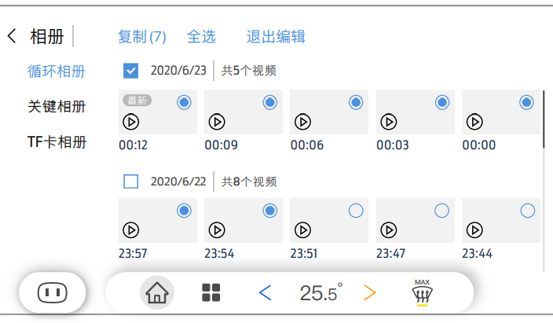

Figure 4-20 Data Copy Example

#### XXXXX-REQ-xxxxxx/A- Smart Copy to TF Card

For better user experience, DVR user could click the “Smart Copy” button on DVR main page to quickly copy the latest two normal videos from eMMC to TF card.

#### XXXXX-REQ-xxxxxx/A- Data Copy to Smartphone

In video/photo playback menu of DVROffboardClient, user could choose one or more data to be copied to smartphone.

#### XXXXX-REQ-xxxxxx/A- Data Copy Special Scenario

If power of DVRServer is cut off suddenly during copy, DVRServer will not save the copy status.

If same data is chosen to copy again, the new data will overwrite the old data.

#### XXXXX-REQ-xxxxxx/A- Memory Full Notification

If TF card or smartphone local memory is near to full, warning message should be showed to customer.

#### XXXXX-REQ-xxxxxx/A- Data Deletion in TF card

In TF card folder playback menu, user could choose one or more data to be deleted via DVROnboardClient.

### Use Cases

#### XXXXX-UC-REQ-xxxxxx/A- Data Copy to TF Card via DVROnboardClient

|  |  |
| --- | --- |
| **Actors** | User, DVRServer, DVROnboardClient |
| **Pre-conditions** | DVRServer is in full power mode |
| **Scenario Description** | User selects one or more videos/photos in playback menu, and click “Copy to TF card” button |
| **Post-conditions** | Selected videos or photos are copied form DVRServer eMMC to TF card folder  A “successfully copy” message should be display on DVROnboardClient HMI |
| **List of Exception Use Cases** | Failed to Data copy and deletion |
| **Interfaces** | HMI, UART |

Table 4-18 Data Copy to TF Card

#### XXXXX-UC-REQ-xxxxxx/A- One-Click Smart Copy Video to TF Card

|  |  |
| --- | --- |
| **Actors** | User, DVRServer, DVROnboardClient |
| **Pre-conditions** | DVRServer is in full power mode |
| **Scenario Description** | User chooses “One-Click Copy” button on DVR main page |
| **Post-conditions** | The latest two normal video in DVRServer eMMC is copied into TF card folder  A “successfully copy” message should be display on DVROnboardClient HMI |
| **List of Exception Use Cases** | Failed to Data copy and deletion |
| **Interfaces** | HMI, UART |

Table 4-19 Smart Copy to TF Card

#### XXXXX-UC-REQ-xxxxxx/A- Data Copy to Smartphone

|  |  |
| --- | --- |
| **Actors** | User, DVRServer, DVROffboardClient |
| **Pre-conditions** | DVRServer is in full power mode  Wi-Fi connection is setup between DVRServer and DVROffboardClient |
| **Scenario Description** | User selects one or more videos/photos in playback menu, and click “Copy to Smart Phone” button |
| **Post-conditions** | Selected videos or photos is copied form DVRServer eMMC to smartphone local memory  A “successfully copy” message should be display on DVROffboardClient HMI |
| **List of Exception Use Cases** | Failed to Data copy and deletion |
| **Interfaces** | HMI, Wi-Fi |

Table 4-20 Data Copy to Smartphone

#### XXXXX-UC-REQ-xxxxxx/A- TF Card Data Deletion via DVROnboardClient

|  |  |
| --- | --- |
| **Actors** | User, DVRServer, DVROnboardClient |
| **Pre-conditions** | DVRServer is in full power mode |
| **Scenario Description** | User selects one or more videos/photos in TF card folder, and click “Delete” button |
| **Post-conditions** | Selected videos or photos is deleted from TF card  A “successfully deletion” message should be display on DVROnboardClient HMI |
| **List of Exception Use Cases** | Failed to Data copy and deletion |
| **Interfaces** | HMI, UART |

Table 4-21 TF Card Data Deletion

#### XXXXX-UC-REQ-xxxxxx/A- Failed to Data Copy and Deletion

|  |  |
| --- | --- |
| **Actors** | User, DVRServer, DVROnboardClient, DVROffboardClient |
| **Pre-conditions** | DVRServer is in full power mode  eMMC or TF card or Wi-Fi connection is not available |
| **Scenario Description** | User try to perform any data copy or deletion action |
| **Post-conditions** | Failed to do data copy or deletion operation  A “Operation Fail” message should be display on DVROnboardClient or DVROffboardClient HMI |
| **List of Exception Use Cases** |  |
| **Interfaces** | HMI, UART, Wi-Fi |

Table 4-22 Data Copy and Deletion Failed

### White Box View

#### Activity Diagrams

##### XXXXX-ACT-REQ-xxxxxx/A- Data Copy to TF Card via DVROnboardClient

*DVROffboardClient related logic is optional, will not be supported on FNV2.1.

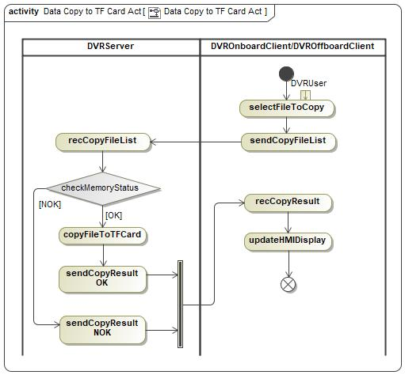

Figure 4-21 Data Copy to TF Card

##### XXXXX-ACT-REQ-xxxxxx/A- Data Copy to Smartphone via DVROffboardClient

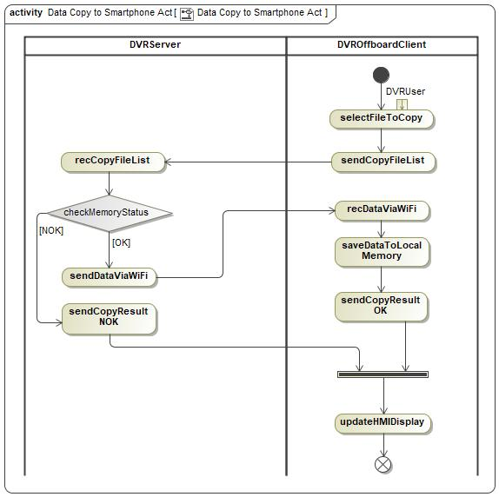

Figure 4-22 Data Copy to Smartphone

##### XXXXX-ACT-REQ-xxxxxx/A- Delete data in TF Card via DVROnboardClient

*DVROffboardClient related logic is optional, will not be supported on FNV2.1.

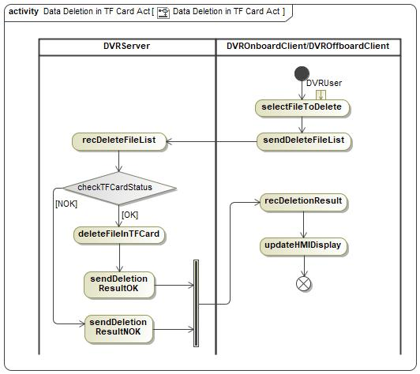

Figure 4-23 TF Card Data Deletion

## XXXXX-FUN-REQ-xxxxxx/A-Vehicle Monitoring

### Requirements

DVR system shall provide vehicle monitor function after user left the vehicle, when DVR system is in standby power mode, DVRServer shall provide the ability to detect external collision and wakeup itself to do video recording, the monitor duration is controlled by Vehicle Monitor Timer.

#### XXXXX-REQ-xxxxxx/A-Collision Detection

The G-Sensor in DVRServer works as acceleration transducer, if acceleration test result is more than a threshold, vehicle monitor video record should be triggered, the threshold should be set via vehicle level calibration and configurable.

#### XXXXX-REQ-xxxxxx/A- Video Record When Vehicle Monitoring

The DVRServer shall wake up and take a video when vehicle monitor triggered, the video should contain 30 seconds (default value which could be changed through DVR setting) after collision detected with default watermark, and during one standby mode cycle, max to 10 videos could be recorded and saved into DVRServer eMMC “Key Data” folder,

#### XXXXX-REQ-422219/A- Wakeup Strategy

DVRServer shall only wake up itself in 2 seconds after collision detected, and should not send out any UART message to DVROnboardClient or Wi-Fi message to DVROffboardClient.

#### XXXXX-REQ-xxxxxx/A- User Notification

When DVRServer goes into full power mode on next ignition cycle, if vehicle monitor video record happened in last standby mode, a warning message should be displayed on DVROnboardClient to notify user that vehicle collision happened.

### Use Cases

#### XXXXX-UC-REQ-xxxxxx/A-Video Record When Vehicle Monitoring Successfully

|  |  |
| --- | --- |
| **Actors** | User, DVRServer, DVROnboardClient |
| **Pre-conditions** | Video record is enabled  DVRServer is in standby mode  DVRServer memory device is available, and no error detected  Vehicle collision is detected |
| **Scenario Description** | DVRServer wakes up and perform video record |
| **Post-conditions** | The new video is saved into eMMC “Critical Video” folder  DVRServer shall send message to DVROnboardClient to highlight this event when goes to full power mode next time. |
| **List of Exception Use Cases** | Failed to Video Record When Vehicle Monitoring |
| **Interfaces** | HMI, UART |

Table 4-23 Vehicle Monitoring Video Capture Successfully

#### XXXXX-UC-REQ-xxxxxx/A- Failed to Video Record When Vehicle Monitoring

|  |  |
| --- | --- |
| **Actors** | User, DVRServer, DVROnboardClient |
| **Pre-conditions** | Video record is enabled  DVRServer is in standby mode  Vehicle collision is detected |
| **Scenario Description** | DVRServer wakes up but failed to perform video record |
| **Post-conditions** | DVRServer shall send message to DVROnboardClient to highlight this event when goes to full power mode next time. |
| **List of Exception Use Cases** |  |
| **Interfaces** | HMI, UART |

Table 4-24 Vehicle Monitoring Video Capture Failed

### White Box View

#### Activity Diagrams

##### XXXXX-ACT-REQ-xxxxxx/A- Video Record When Vehicle Monitoring

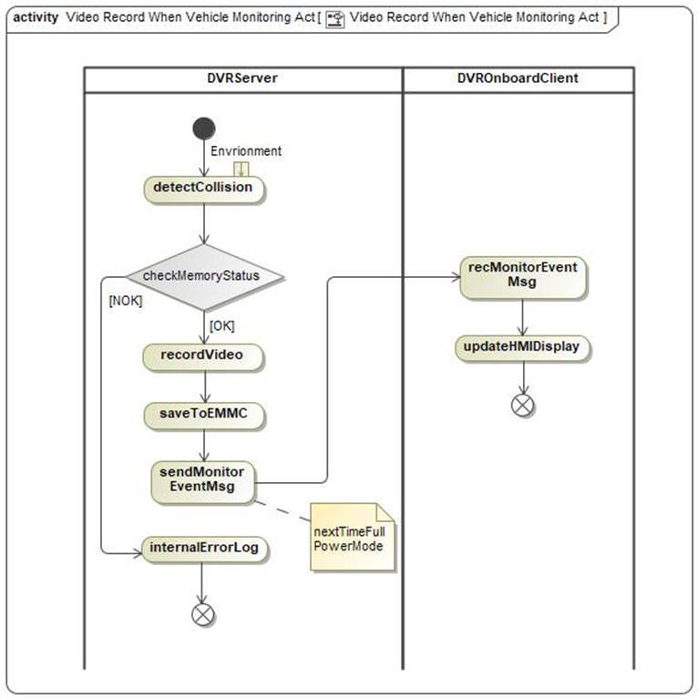

Figure 4-24 Vehicle Monitoring Video Capture

# Appendix: Reference Documents

|  |  |
| --- | --- |
| Reference # | Document Title |
| 1 | F006930_Drive Video Record Feature B-Diagram |
| 2 | F006930_Dirve Video Record Feature Implementation Spec |
| 3 | F006930_Drive Video Record Feature UART Protocol |
| 4 | Integrated Dash Camera Module Specification |
| 5 | 【CX771&CX821】UE_行车记录仪 |
| 6 | GBT 38892-2020 CN |

Table 4-25 Reference Documents